Nuclear Beta Decay Analysis: Procedure Proposal

Alex Stothart - 10065239, Colin MacLeod – 10151666, & Zach Mirotta – 101…

ENPH 453

January 20th, 2018

## Goals

This experiment aims to accomplish 3 principle goals:

* Observe β- decay of 128I nuclei
* Estimate the mass of the anti-neutrino produced in the decay
* Determine the half life of the 128I isotope

The energy values of the electrons emitted in the decay will be recorded, and the shape of this energy spectrum can be examined to verify if it matches the expected distribution. The upper limiting energy value observed can be used to estimate a value for the anti-neutrino mass. The number of observed decays can be recorded over fixed time intervals, and this data can be fit to an exponential decay curve to obtain a value for the half-life of the isotope.

## Background

## Beta Decay

Beta decay is a form of radioactive decay involving the transformation of a neutron into a proton or vice versa. Beta decay emits a high-energy electron or positron, known as beta rays. There are three types of beta decay: β+ decay, β- decay, and electron capture. β+ decay involves that transformation of a proton into a neutron, emitting a positron and neutrino. Β- occurs when a neutron transforms into a proton, emitting an electron and anti-neutrino. Electron capture is the process of an inner electron being captured by a proton in the nucleus, transforming it into a neutron and emitting a neutrino. Several factors contribute to beta decay; mainly, the total number of nuclides and the number of protons. If there is a large number of protons in an atom the Coulomb repulsion between them increases the energy, in which case it would be favourable to transform proton into a neutron, resulting in β+ decay. If there is a large number of protons in a nucleus then, based on Pauli’s exclusion principle, neutrons will be forced into high energy states, in which case β- decay may occur. This lab will be studying the β- decay of 128I. A method of inducing β- decay is to enrich a stable source with additional neutrons. The added neutrons will likely decay to protons, depending on the source. The energy of the process is termed the Q value. The Q value is the difference between the mass of the reactants and products. The Q value of 128I β- decay was calculated to be 2121 keV by subtracting the mass excess of 128Xe from the mass excess of 128I. The kinetic energy of the emitted electron, mass of the emitted neutrino, and kinetic energy of the neutrino sum to the Q value. The mass of the emitted neutrino can be calculated by subtracting both kinetic energies from the Q value.

## Beta Spectrum

The beta spectrum is a histogram plot of the energy of the electron emitted in β- decay. The energy of the electron can be used to determine the kinetic and mass energy of the emitted neutrino. At the maximum possible electron energy, the neutrino would theoretically have no kinetic energy. If the neutrino has no kinetic energy, then the energy that is not accounted for in the electron kinetic energy is the mass energy of the neutrino. The maximum kinetic energy of the electron is the x-intercept of the beta spectrum. The β- spectrum shape is that of a gaussian distribution skewed towards low energies. The distribution is skewed because of the Coulomb force slowing the electrons down to lower energies as they are emitted. For β+ decay the spectrum is skewed to high energies for the same reason. The spectrum can be linearized into a Kurie plot which clearly shows the intercept. The spectrum data is linearized by plotting the square root of the counts divided by the respective Fermi function versus energy.

## Apparatus

A sodium iodide crystal, specifically a Bicron 3M3/3 NaI crystal, will be used as both the source and detector for the beta decay in this experiment. This crystal will be surrounded by lead in order to isolate it from other radiation sources that may be present. Using neutron capture, the iodine 127 in the crystal will be used to create iodine 128, which is a source of beta minus decay. The crystal will also be used as a scintillator detector, and a photomultiplier tube (PMT) will be used to capture the signal given off by the crystal. This photomultiplier tube will be biased at 800 volts by an Ortec 459 0-5 kV bias voltage supply. The signal through from the photomultiplier will be amplified through a Ortec 572A amplifier, so that it can be read by a multichannel analyzer (MCA). A Tektronix TDS3012B 2 channel oscilloscope will be used to monitor the signal from the amplifier so the gain can be set to an appropriate level. The data from the multichannel analyzer will be analyzed using a PC running Maestro32 MCA software, where the data can be collected and stored.

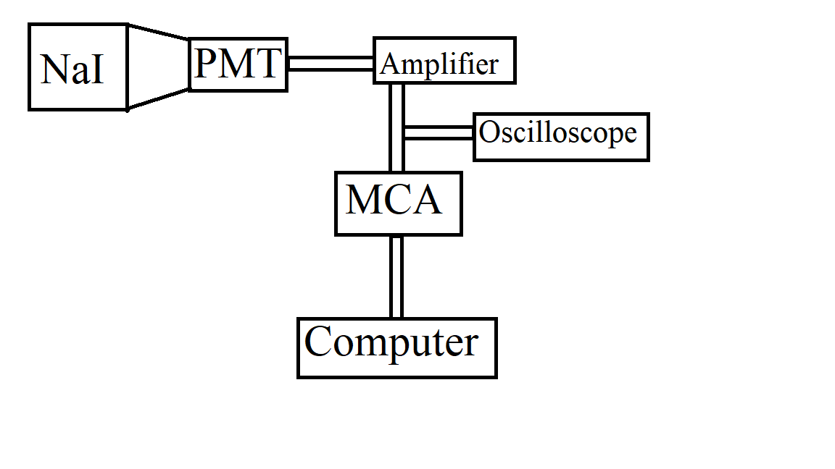

Figure : Diagram of Experimental Apparatus

## Experimental Procedure

### Setup

Prior to the collection of nuclear decay data, several preparatory steps needed to be completed to ensure that the experimental results are valid and useful.

#### Energy Range Selection and Calibration

The emitted electron energies were amplified, and then recorded using MCA software and sorted into channels based on energy level. This data was plotted in a histogram with a bin corresponding to each channel. Prior to this, however, the energy values corresponding to the histogram channels needed to be calibrated, and the amplifier gain needed to be tuned so that the upper end of the range over which this histogram spans encapsulates all expected energy values, and yields channel widths small enough to provide as much precision as possible. No emitted electrons are expected to have an energy greater than the Q-value of the decay, namely 2121 keV, meaning the upper limit of the histogram bin was set slightly above this value. The procedure followed to accomplish this is described below.

The experimental apparatus was turned on and the voltage source was adjusted until it sat at roughly 800 V. Throughout the experiment, the voltmeter was monitored to ensure no noticeable voltage drift occurred.

The __ isotope was selected for use as a reference, since the combination of two expected γ-decays lead to a peak with an energy of approximately ___ keV, a value just greater than the Q-value of the β-decay studied. Although γ-decay is a different process than β-decay, it can still be used for this purpose, as the particles produced in γ-decay initiate the same interactions, and the same data recording process in the scintillator as β-decay, meaning particles emitted with a certain energy will be recorded in the same MCA channel, regardless of the origin of the particles. The isotope was signed out of the radioactive materials log, and placed into the lead casing positioned next to the NaI scintillator detector. The oscilloscope was turned on to see that there were in fact decay events being observed. The MCA software was turned on to observe the relative energy levels of these decays. The gain was tuned so that the observed peak with the highest energy (the __ keV peak) fell at the far right edge of the histogram display. The desired gain value was recorded, and the amplifier was set to this value and locked. The source was then returned to the radioactive materials case.

__ , __, __, __, and __ isotopes were also selected for use as a reference, as they were expected to produce γ-decay peaks at ___, ___, ___, ___, and ___ respectively. These isotopes were selected as they produce peaks at a range of energies that covers a span similar to the expected β-decay spectrum. Although many of these isotopes produce multiple energy peaks (some resulting from single decay events, and some resulting from a combination of single events being recorded at the same time), the relative positioning of the peaks on the histogram display allowed them to be distinguished and associated with their expected energy levels. The channel number data resulting from these isotopes was recorded, so that gaussian distributions could be fit to the produced peaks, giving a mean channel number, and error on the mean value for each. A linear fit could then be performed on the mean channel numbers and expected energy levels at each recorded peak to determine a calibration factor between energy level and channel number.

#### Energy Resolution Determination

The intrinsic lack of precision of the data collection and recording equipment needed be accounted for when analysing experimental data, meaning the resolution of the energy value recordings needed to be determined. This was done using the same γ-decay energy data recorded to calibrate channel and energy level. The full width at half maximum of the peaks was noted for each isotopes, and was taken to represent the energy resolution at that specific energy level. This would allow the resolution to be observed as a function of particle energy. It should be noted that not all of the peaks used to calibrate channel number and energy were used to determine energy resolution, as some of these peaks resulted from the sum of two γ-decay events. This sum means that the resolution at that point would include the imprecision of both decay events involved, and would lead to a peak width that is not truly representative of the resolution at that energy level. For this reason, the __, and __ isotopes were not used to determine resolution.

#### Background Noise Recording

The final preparatory step before data can be recorded is the recording of background noise, so that this can eventually be removed from the experimental data. The apparatus was turned on and left to collect data over a period of 45 hours with no activated source present. As a result, all data collected came from background events that are not wanted when trying to analyse the β-decay spectrum. This process was repeated a second time following a later lab period, this time for 117 hours to ensure that the obtained data truly represents the consistent background noise. In both cases, the noise data will be normalized for the given recording time period, so that it can a proportional amount of noise can be subtracted from the actual β-decay data.

### Data Collection

Once all the setup steps were completed, the beta decay was observed, and the experimental data collected.

The Iodine in the NaI crystal was activated for roughly 5 minutes using the AmBe neutron source. The scintillator was inserted into the holding sleeve, and lowered into the neutron source. The source was closed, and left for 5 minutes before the scintillator was removed.

Once activated, the NaI crystal scintillator was reconnected to the PMT, and the β- decay events were observed. The energy of the electrons emitted in the decay were recorded in the previously calibrated histogram using the MCA. The data was recorded for roughly 25 minutes, and the spectrum was saved every 5 minutes so that the decay could be investigated within these intervals.

## Data Analysis

Several steps were taken to refine the recorded data before it was used to calculate neutrino mass. The first correction to be made to the data was to remove the background noise. Since both recordings of background noise displayed very similar trends, the second set was used, since it was recorded over a longer period, and therefore random events will have had less of a relative effect. The counts recorded in each energy level bin were divided by the recording time in seconds. This normalized set was then subtracted from each recorded β-decay dataset, after first multiplying it by the respective recording time interval.

The first and last 100 data points were then removed from the sets, as they are not essential to the goals of the experiment, and they display a trend that…

It was then necessary to deconvolve the energy resolution distribution from the β-decay data. It was initially attempted to deconvolve the resolution as a function of energy; however, upon further investigation, this involved complex mathematical analysis that falls beyond the scope and timeline of the present experiment. This may be worthwhile to investigate if the experiment was to be expanded, and further time was to be committed to it. Instead, a constant energy resolution value was selected. The constant value selected was the resolution at the Q-value of the experiment, as this is very close to upper limit of the beta spectrum, which is the point in the distribution most important to the estimation of the anti-neutrino mass. The deconvolution was done by performing a Fourier Transform on the recorded β-spectrum, and a Fourier Transform on a Gaussian distribution with a standard deviation equal to the selected energy resolution. The transformed β-spectrum was then divided by the transformed Gaussian distribution, and an inverse transform was then performed on the resulting data. The deconvolved data appeared almost identical to the original data, but it was used for further analysis nonetheless.

Once the background noise had been removed, and the detector resolution accounted for, the data could be used to arrive at an estimation of anti-neutrino mass. The β-spectrum was manipulated into a Kurie plot, so as to linearize the data as it approaches the horizontal axis. The manipulation involved taking the square root of the recorded counts in each channel, and dividing it by the Fermi function of the associated energy level.

A linear fit was then performed on the portion of the Kurie plot that approached the horizontal axis, and its intersection with this axis was determined. This intersection represents the highest recorded electron energy, meaning all of the kinetic energy of released particles went to the electron, and none to the anti-neutrino. The difference between the Q-value and this electron energy gives the mass energy of the anti-neutrino.

Once the data has been obtained, the background radiation will be removed by comparing the electron energy data to the background data taken earlier. A deconvolution will also be undertaken in order to remove any effects of the detector resolution. This will be done using the detector energy resolution data collected in the experimental setup. This resolution will be in the form of a Gaussian function which can be deconvolved from the data. The resolution of the detector was analyzed at different energies, so that the correct resolution is used in the deconvolution, as the resolution may be energy dependant. The data will be converted to a Kurie plot in order to analyze the intercept, which determines the end point energy. In order to convert the data to a Kurie plot, the square root of the number of counts divided by a fermi function will be compared to the energy of the electron.

## Physics Analysis

Once the end point energy of the electron has been established, the total energy contained in the neutrino can be evaluated by comparing the endpoint energy to the Q value of the reaction. In an ideal system, the neutrino would be created with no kinetic energy, so the total energy calculated for the neutrino would be contained solely in its mass, and thus the mass of the neutrino can be calculated. However, this situation is unlikely to be seen using the equipment in this experiment, and so the energy of the neutrino will be used to determine a rough upper limit on the mass of the neutrino. It will also be useful to examine the shape of the spectrum produced in the experiment, as it will be helpful for examining sources of background radiation, as well as matching the curve to the expected model through use of a Kurie plot. The intercept of the Kurie plot will be used for determining the endpoint energy of the electron. Calculations of the decay half life of 128I will also be carried out, and compared to the known half life of 24.9 minutes (Isotope Data for Iodine 128, 2018).

## Results

Two trials were conducted to observe the β-decay spectrum. The unaltered data for the first and second trials are shown in Figures 2 and 3 respectively.

The refined datasets are plotted in Figures 4 and 5 repsectively.

Kurie plots for each dataset are shown in Figures 6 and 7.

A linear regression was fit to the linear portion of the Kurie plot (from electron energies between roughly 1.5 MeV and 1.9 MeV), and the line extended to it’s intersection with the horizontal axis. The point at which it intersects represents the upper limit of observed electron energies. This value was subtracted from the Q-value to obtain a value for the mass energy of the emitted anti-neutrino. The anti-neatruino masses determined from each trial are displayed in Table 1.

|  |  |  |
| --- | --- | --- |
| Trial | Value | Uncertainty |
| 5 minute source activation | 20. keV/c2 | 1 keV/c2 |
| 10 minute source activation | 49 keV/c2 | 3 keV/c2 |

Figure 8 below shows the exponential decay if 128I Nuclei. Note that the vertical axis value were selected arbitrarily to display the decay, as the do not impact the obtained decay constant.

An exponential fit performed on the data yielded a decay rate of 6.8x10-4 s-1 ± 0.8x10-4 s-1.

## Discussion

The recorded β-spectra display the expected trend and match the predicted spectra shape. The obtained antineutrino mass values are both larger than the accepted anti-neutrino mass of 0.12 eV/c2; however, they are once again relatively close to this value given the scale of the electron energies observed, and the accuracy and precision of the experimental apparatus. The MCA channels each correspond to an energy range of roughly 1.4 keV, which is itself much larger than the mass of an anti-neutrino. Although detector resolution, channel to energy calibration error, and statistical error in the number of counts were all accounted for to obtain the final result, the uncertainty on the value obtained is too low, as it should be at roughly as large as the value itself in order to truly be consistent with the accepted mass. This is likely due to the inability to completely account for the previously mentioned error sources, as well as the inability to completely remove background noise.

It should also be noted that the obtained values represent an upper limit on the mass, not the mass itself. The difference between decay Q-value and upper limiting electron energy represents the sum of the anti-neutrino mass energy and kinetic energy. In reality, the emitted anti-neutrinos will likely possess a significant amount of kinetic energy, meaning the mass energy would be substantially less than the values displayed in Table 1.

Surprisingly, the trial in which the source was activated for 10 minutes yielded a higher anti-neutrino energy. It was expected that the recording pile-up resulting from the more active source would shift the electron energy spectrum towards higher values, which would yield a lower anti-neutrino energy. This suggests that it is unlikely that pile-up impacted the obtained results; however, additional trials over a range of activation times would be needed to observe if there is any correlation between activation time and the obtained mass value. Although the trials yielded two different masses that are not equal within uncertainty, the values are very close given the scale of electron energies observed, and the difference may simply be caused by the inability to completely account for background noise, detection resolution, and equipment inaccuracy.

The obtained decay rate also did not match the accepted value of 4.6x10-4 s-1, although it is relatively close. The discrepancy is likely explained by the inability to completely account for the background noise present in the experiment.

## Safety Concerns

Several safety factors need to be considered when executing the experiment. The photomultiplier tube requires a very high voltage of 800V to operate, so caution must be used in operating the photomultiplier tube and its voltage supply. Also, the NaI crystal will be surrounded by lead, which is toxic. Gloves will be worn when handling lead objects. Several sources of ionizing radiation will be required to calibrate the detector, so techniques to minimize any possible exposure to radiation will be used. A neutron source will be required to activate the NaI crystal, so caution must be used when inserting the crystal into the neutron source.

# References

*Isotope Data for Iodine 128*. (2018). Retrieved from periodictable.com: http://www.periodictable.com/Isotopes/053.128/index.p.full.dm.html